**STORAGE UNIT MANAGEMENT SYSTEM**

**USER MANUAL**

**OnesAndZeroes**

**Table of Contents**

**Below is the complete table of contents for the manual:**

**Getting Started**……………………………………………………………………………………………………**……...2**

Introduction…………………………………………………………………………………………………2

Installation ………………………………………………………………………..………………………..2

System Requirements………………………………………………………………………………….2

**The user Interface……………………………………………………………………………………………………..3**

Logging in…………………………………………………………………………………………………….3

Navigate the Storage Unit Management System………………………………………….4

**Clients Tab………………………………………………………………………………………………………………….5**

Adding Clients…………………………………………………………………………………………….5

Removing Clients………………………………………………………………………………………..6

Restoring Clients…………………………………………………………………………………………8

Listing Clients………………………………………………………………………………………………9

**Lease Units Tab……………………………………………………………………………………………………..…….10**

New booking………………………………………………………………………………………………..11

List bookings………………………………………………………………………………………………..13

**Units Tab…………………………………………………………………………………………………………………..…14**

Adding Units…………………………………………………………………………………………….….14

Listing Units……………………………………………………………………………………………..….15

Searching Units……………………………………………………………………………………………16

**System Tab………………………………………………………………………………………………………………..…17**

New Unit pricing…………………………………………………………………………………………..17

New Unit class………………………………………………………………………………………………18

New users…………………………………………………………………………………………………….19

Edit Users…………………………………………………………………………………………………….20

Alrick Visagie : 214086402

Shahbaaz Sheikh : 214066614

Moeketsi Betana : 214110370

Watlinton Moholo : 214030377

THE STORAGE UNIT MANAGEMENT SYSTEM INTERFACE

Welcome to the Unit Management System! You are about to experience the effects of paperless, effective management of Units. The Unit Management System eliminates paper work, making any user’s work of completing necessary tasks easy and efficient. This User Manual provides a detailed description of all the Unit Management System’s features. We are sure you will find the Unit System easy to use. Let’s get started!

Installing the Storage Unit Management System

Run Setup, find program In C:\Progamfiles(x86)\StorageUnitManagementSystem

Computer Requirements

Before managing Units, make sure your computer meets the following requirements:

* Windows XP or higher
* 512 RAM
* 500 MB disk space
* Internet Connection to send Mails

Logging in

Before you can login, you must be provided with a username and password by the owners of the system.

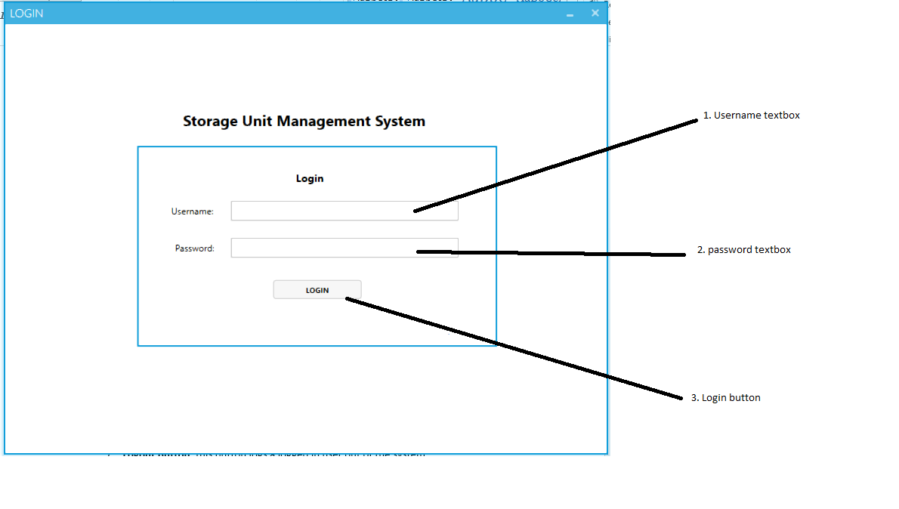

Figure 1

1. **Enter** password in password textbox field
2. **Enter** username in username textbox field
3. **Click** thelogin button. A successful login will show figure 1

Navigating the Storage Unit Management System

The main areas of the Unit Management System are labelled below and are described in detail on the following pages.

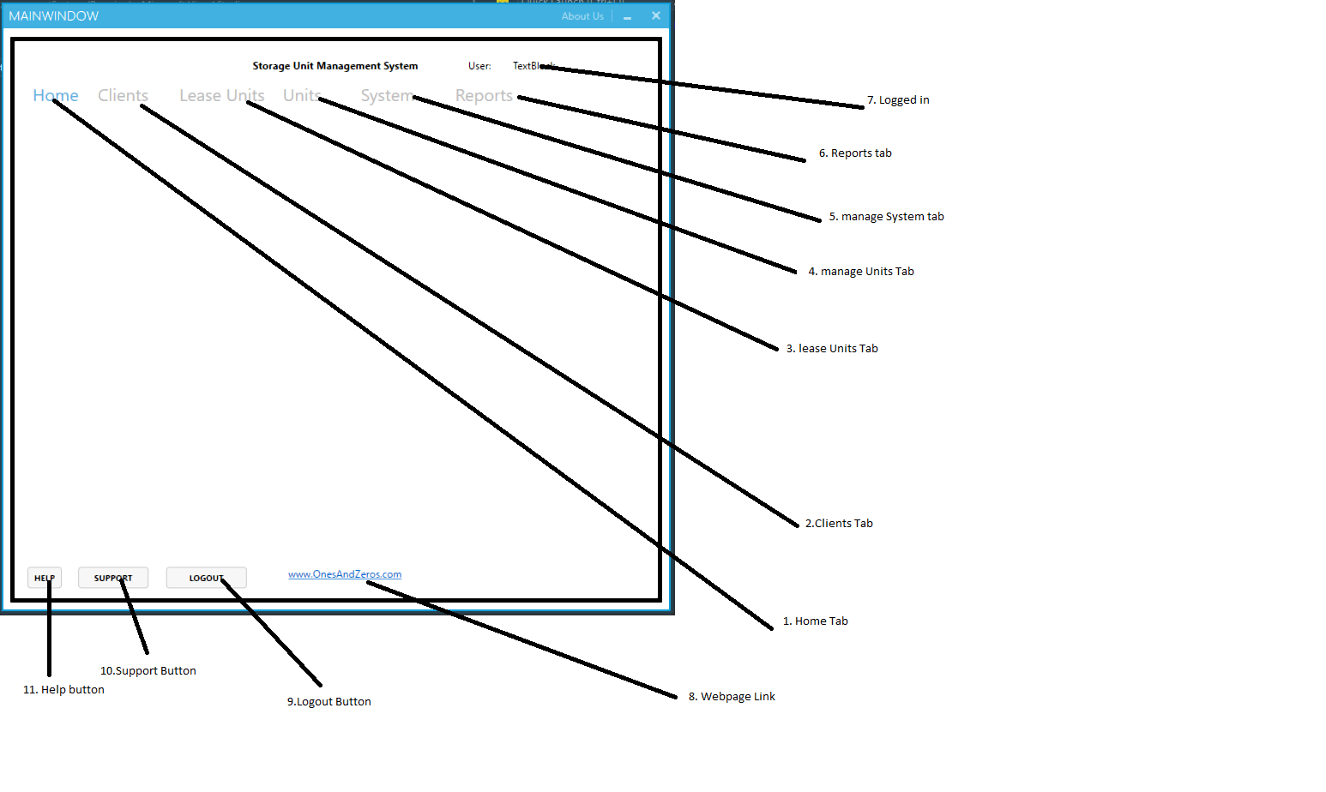

Figure 2. Storage Unit Management System Interface

1. **Home Tab:** this is the first page that shows after a successful login
2. **Clients Tab:** this tab is where clients are managed (add, edit, and delete etc.)
3. **Lease Units Tab:** what does it represent
4. **Manage Units:** this tab manages units (add, edit, and delete etc.)
5. **Manage System Tab:** this tab is where amendments of users and units take place
6. **Reports Tab:** this tab represents all system generated reports (income and expenses reports for clients and units)
7. **Logged in:** this is the current logged in user
8. **Webpage link:** When clicked on, this link that takes the user to the programs website (requires an internet connection)
9. **Logout Button:** this button logs a logged in user out of the system.
10. **Support Button:** this button will connect the user with the developers
11. **Help Button:** this button will take a user to a page where help will be provided

**Clients Tab**

Adding a Client

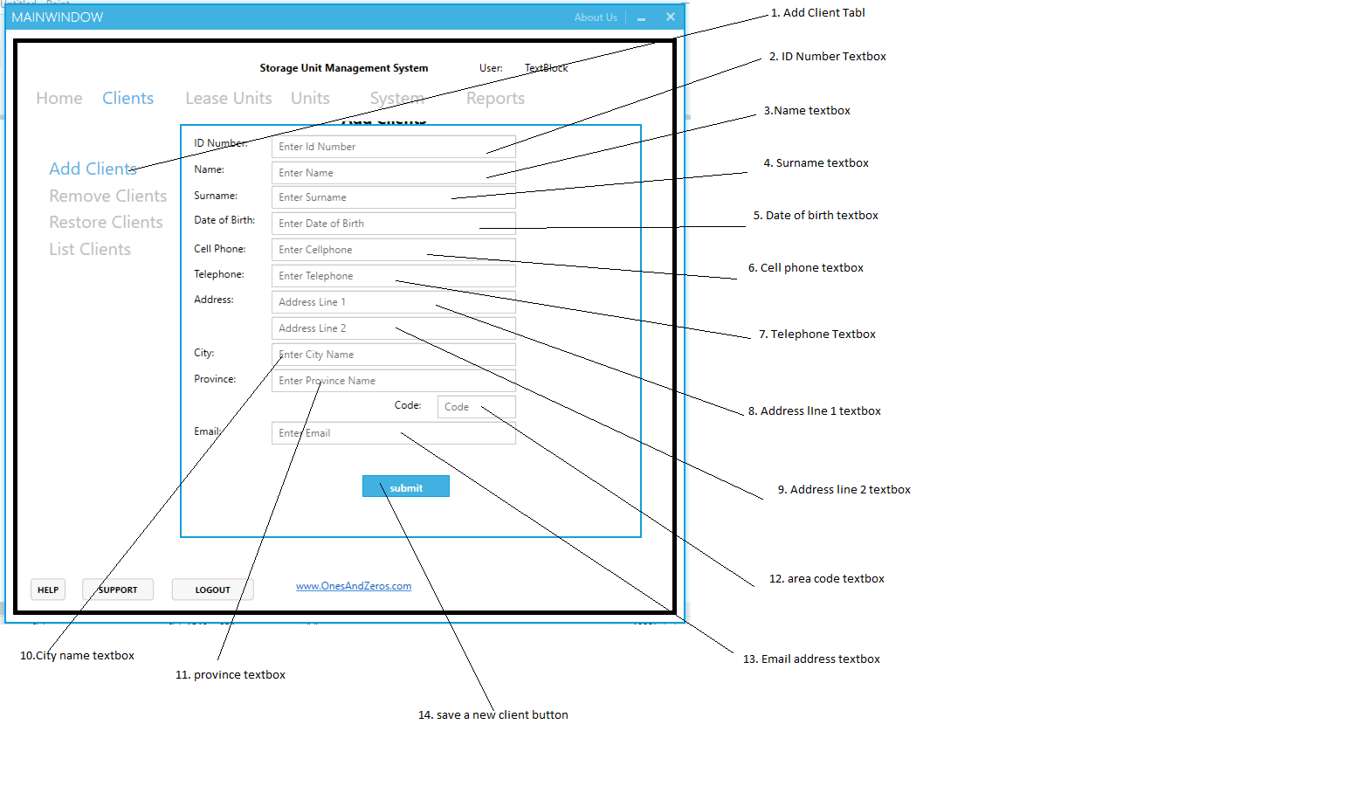

Figure 3.1 add a client interface

Adding a new client

1. **Click** on the **Clients Tab,** the **Add Clients** numbered 1 will display. **Click** on a text box and fill in the relevant information. Example; Click **Name textbox** (numbered 3 on figure 2) and type the name of the Client. Fill in all textboxes with the required information.
2. **Click** the **Submit** button (numbered 13 on figure 2) to add a new client to the database with the provided information from the textbox fields. Figure 2.1 will show if a client has been added successfully to the database, **Click OK** to close the message.

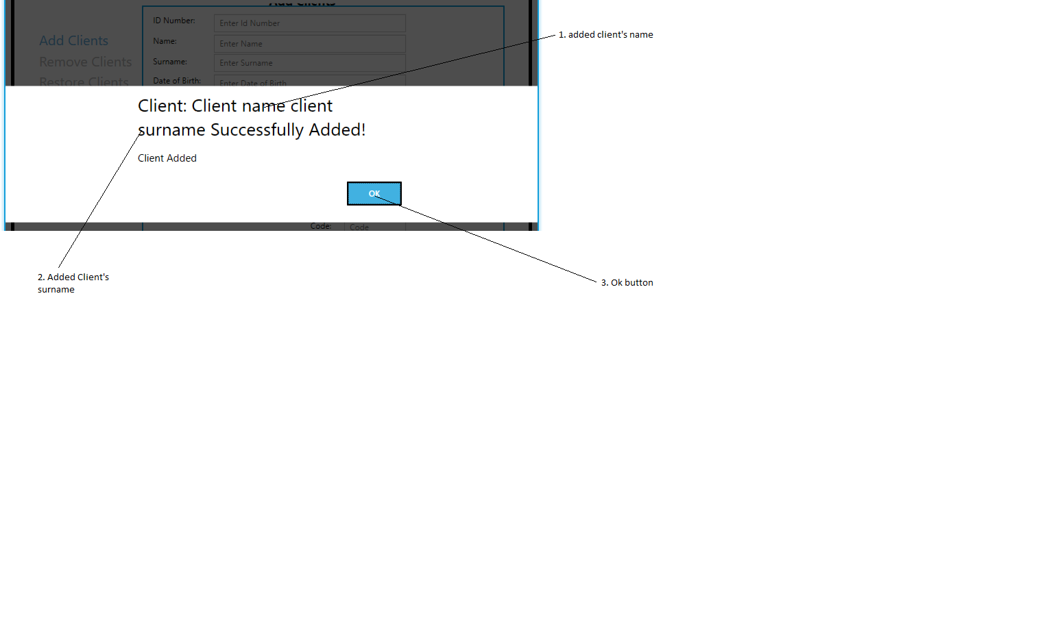

Figure 3.2 client added successfully dialog box interface

Removing Clients tab

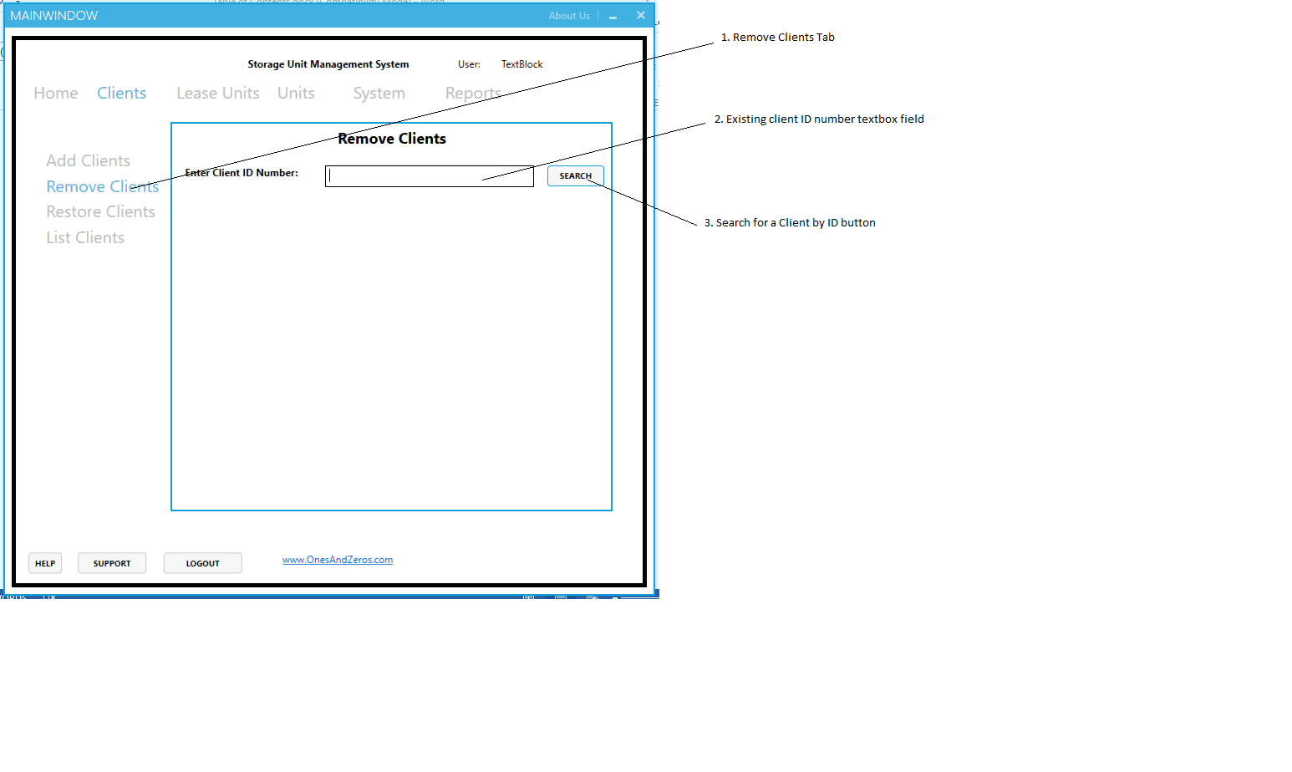

Figure 4.1 Remove Clients Tab interface

To remove a Client you must first search for the client you want to remove. Note: all removed Clients can be restored at any stage if needed.

Searching a client by ID Number

1. Navigate to the **Client Tab** see figure 1. **Click** the **Remove Clients Tab** see figure 3. **Enter** an existing valid Client’s id number in the ID Number textbox field (numbered 2 in figure 3.1).
2. **Click Search** (numbered 3 in figure 3.1). if the entered Id number does not exist in the database a message will show, to tell you the Client was not found, see figure 3.2

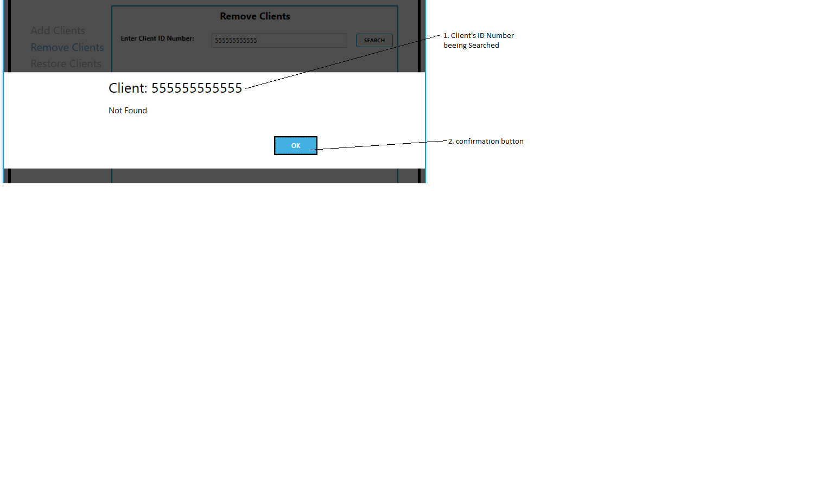

Figure 4.2

1. **Click OK** to close the dialog and search again.

A successful search will show the figure below.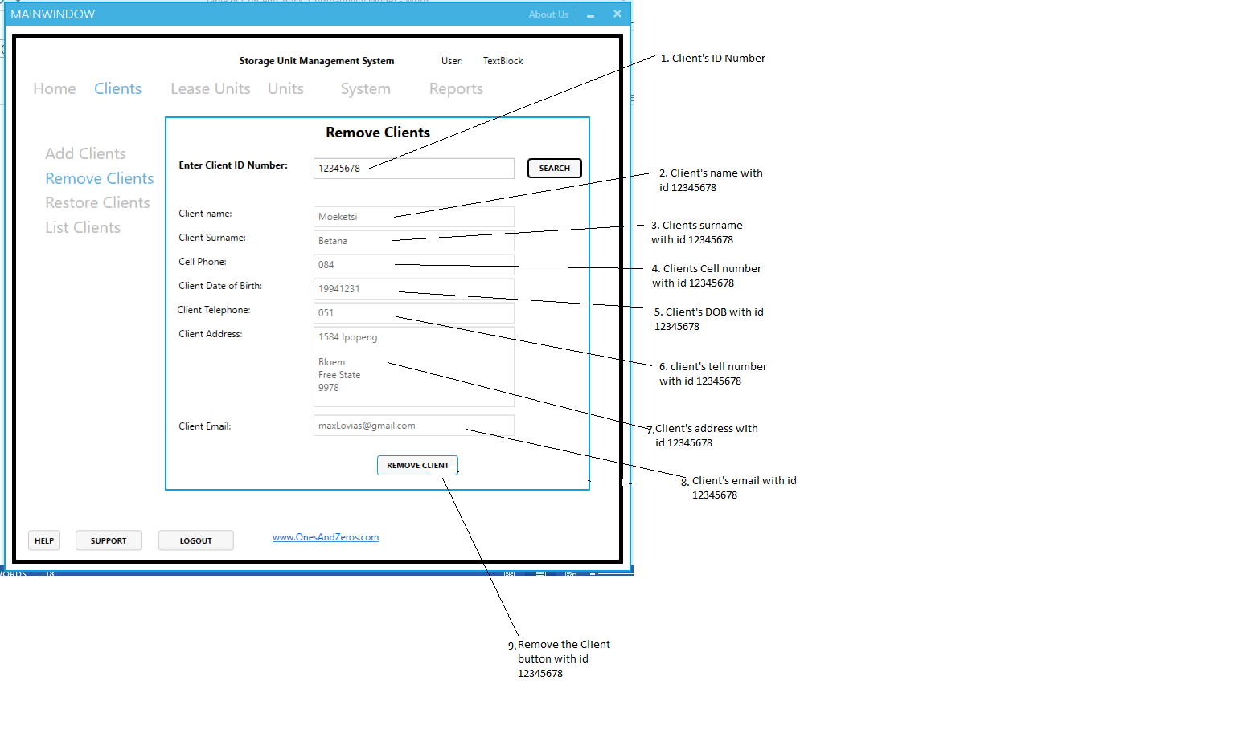

Figure 4.3

Successfully removing a client

1. **Click** the **Remove Client button** to remove a client.

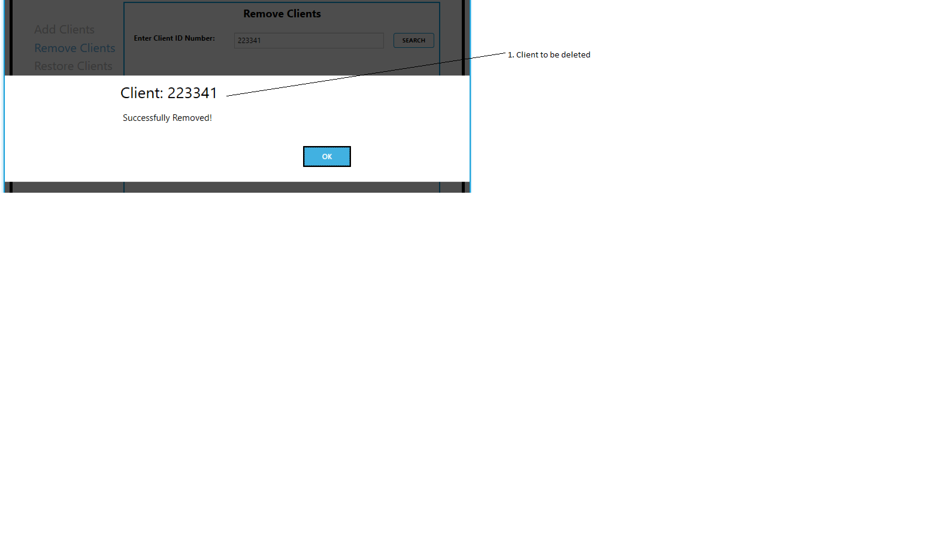

Figure 4.4

If a Client was removed successfully a dialog box will appear (figure 3.4) with the relevant information

1. **Press OK** to close the message, and search for another client to delete or perform a different task

Restore Clients Tab

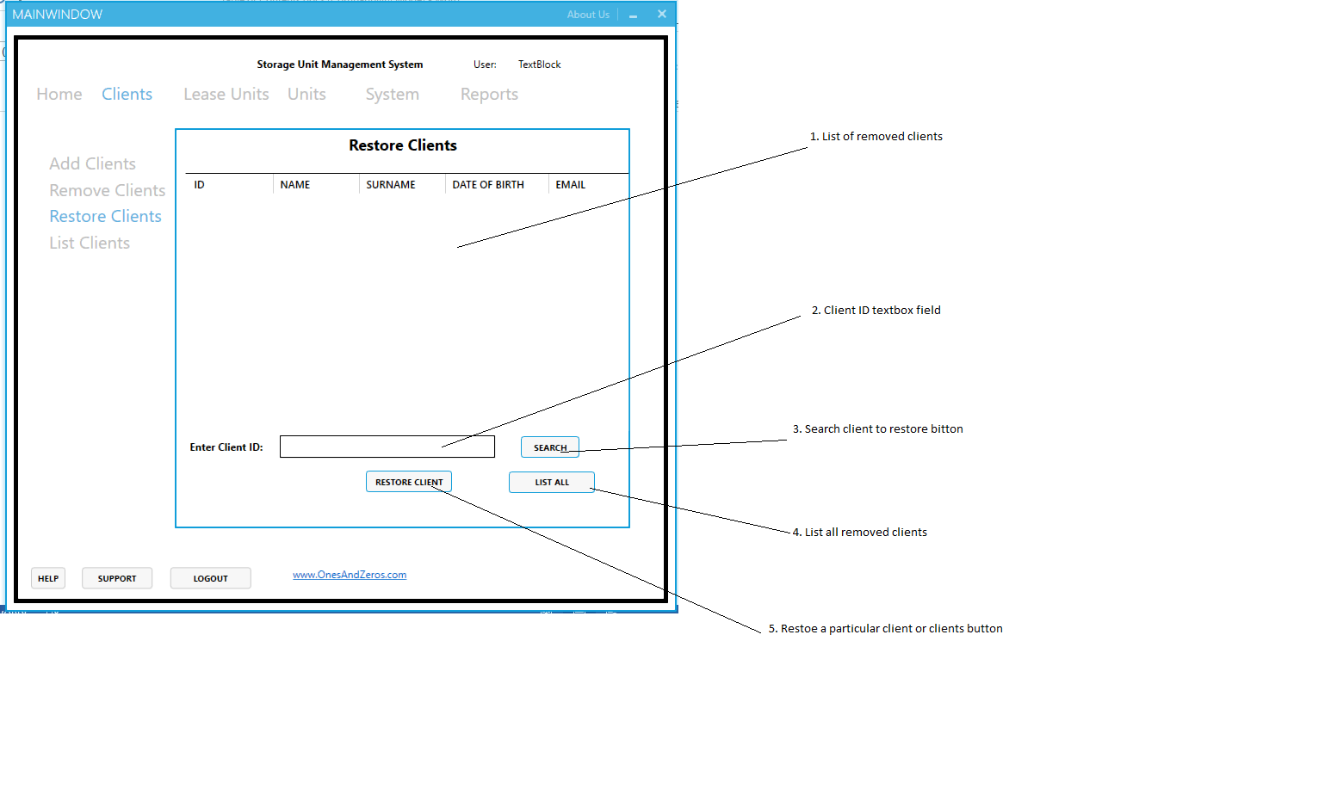

Figure 5.1 Restore Clients Tab interface

Restoring a single Client

1. Navigate to the **Clients Tab** see figure 1. **Click** the **Restore Clients Tab** see figure 4.1
2. **Enter** a removed Client’s ID Number in the Client ID textbox field
3. **Click Search** to search for the client with the provided ID Number. The client’s details will show on the list of removed clients (numbered 2 on figure 4.1)
4. **Click** Restore Client Button to restore the client. See figure 4.2
5. **Click OK** to close the message that displays.

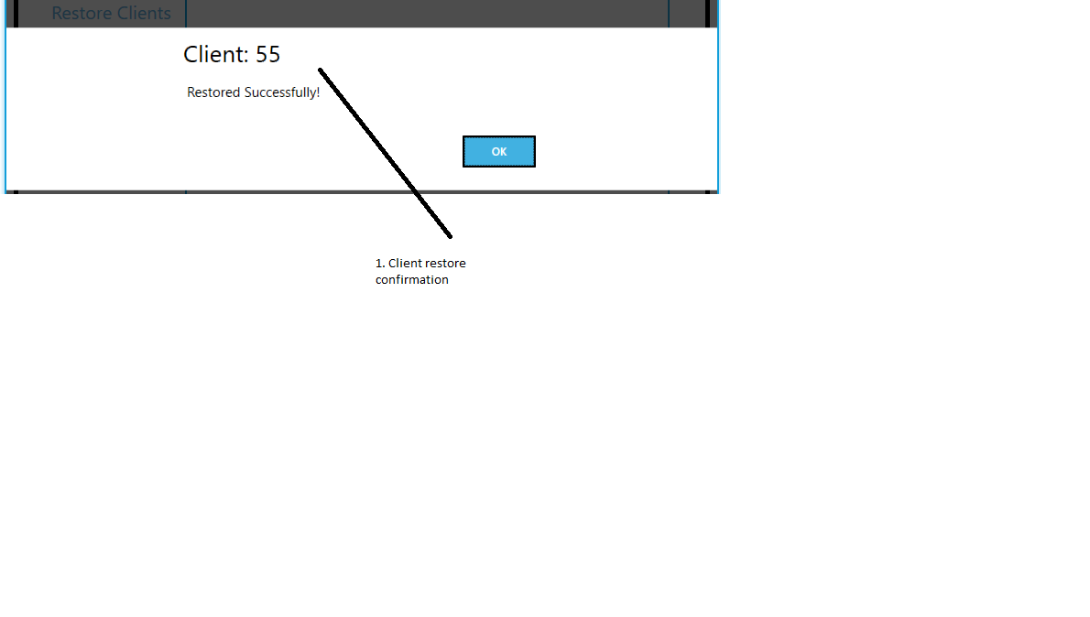

Figure 5.2

Restoring multiple Clients

1. **Click** list all (numbered 4 in figure 4.1). a list of all removed clients will display (See figure 4.2)

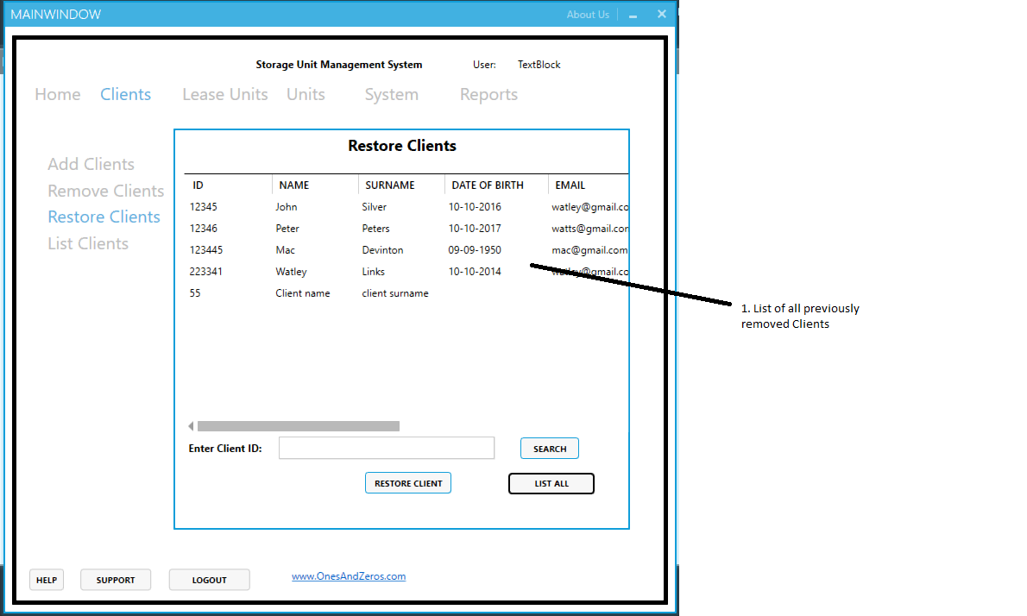

Figure 5.3

1. **Click** Restore Client (numbered 5 in figure 4.1) to restore the clients.

Listing Clients

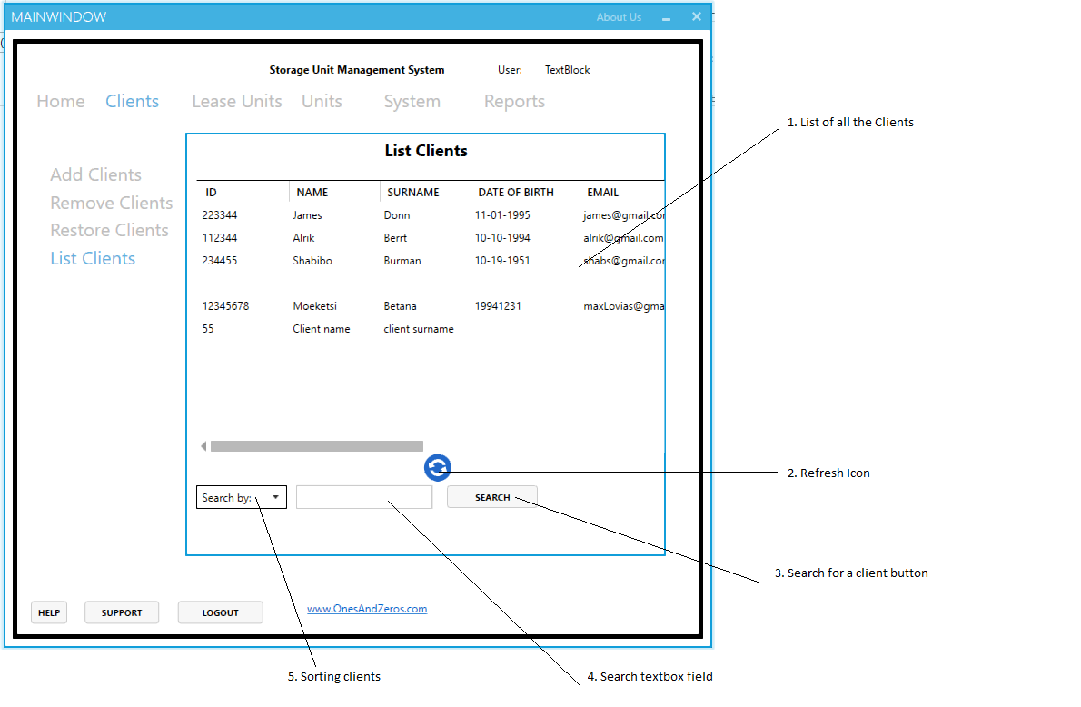

Figure 5.4

1. Navigate to the **Clients Tab** see figure 1.
2. **Click** the **List Clients Tab** see figure 4.1
3. **Click** the REFRESH icon (numbered 2 on figure 4.4) to refresh the list of Clients

Leasing Units

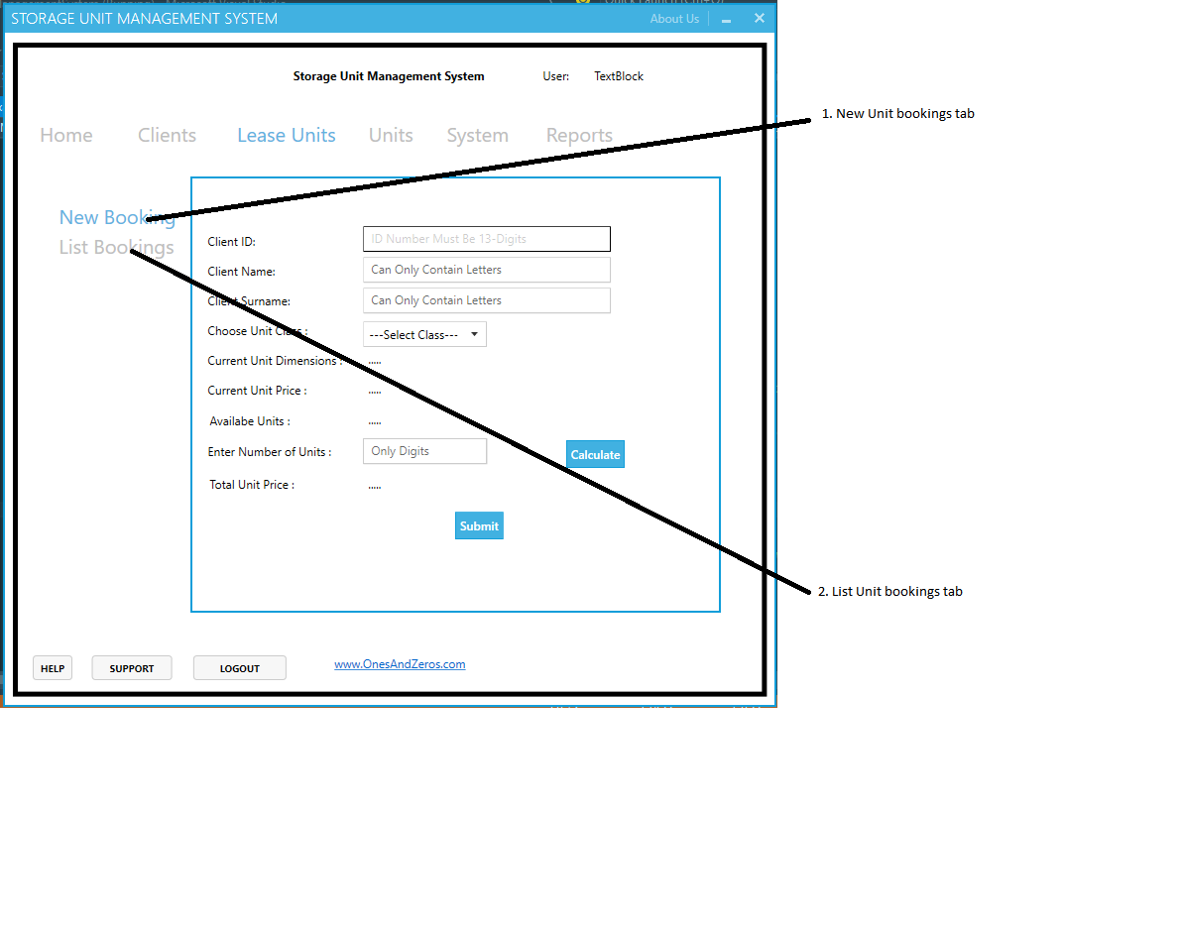

Figure 6.1 Lease Units interface

1. **Select** New bookings tab labelled 1 on figure 5.1 to lease a Unit
2. **Select** List bookings labelled 2 on figure 5.1 to view all lists of Unit bookings

Making new Unit bookings

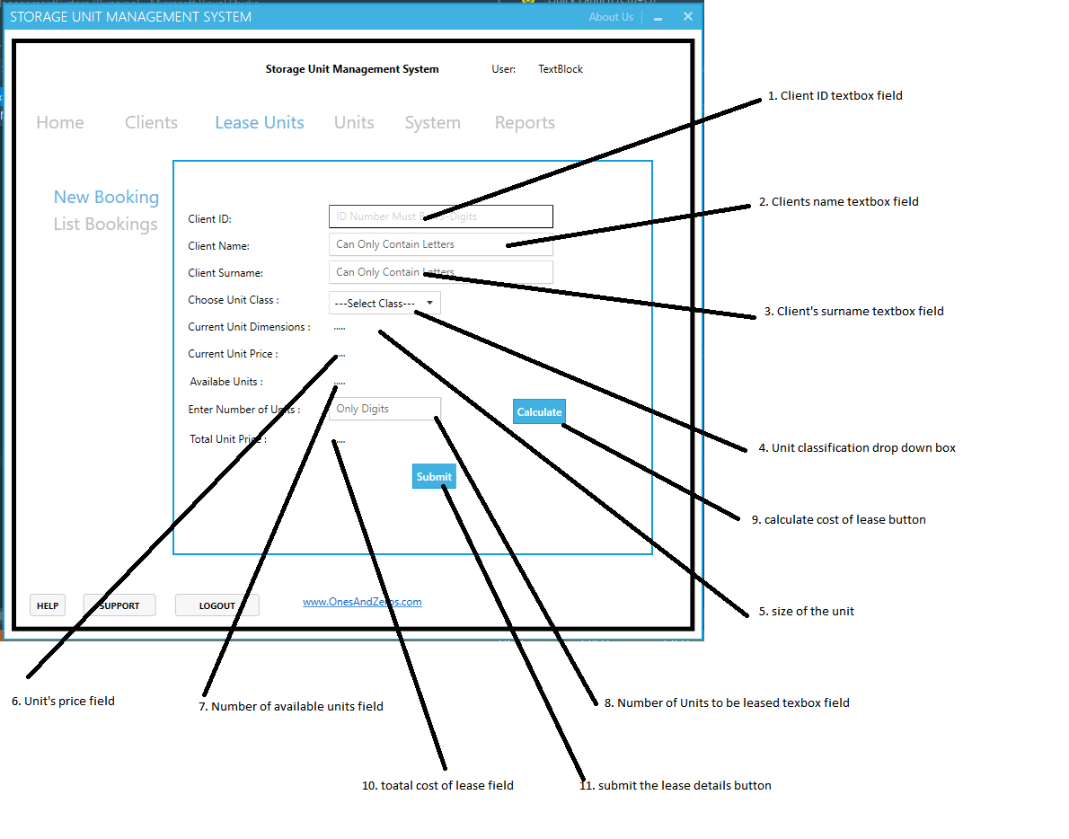

Figure 6.2 new unit booking tab interface

1. **Enter** the client’s unique ID in the textbox labelled 1 on figure 5.2
2. **Enter** the client’s name in the textbox labelled 2 on figure 5.2
3. **Enter** the client’s surname in the textbox labelled 3 on figure 5.2
4. **Select** the unit class (A - F) from the drop down box labelled 4 on figure 5.2, the selected unit class’s current dimensions (labelled 5 on figure 5.2 ) , price (labelled 6 on figure 5.2), and number of available units (labelled 7 on figure 5.2)will display. See figure 5.2.1
5. **Enter** the total number of units to be leased in the textbox field labelled on figure 5.2
6. **Click** Calculate button to see the amount that will be owed. The amount/price of the unit(s) to be payed will be displayed in the text field labelled 10 on figure 5.2. See figure 5.2.1
7. **Click** submit button (labelled 11 on figure 5.2) to save details

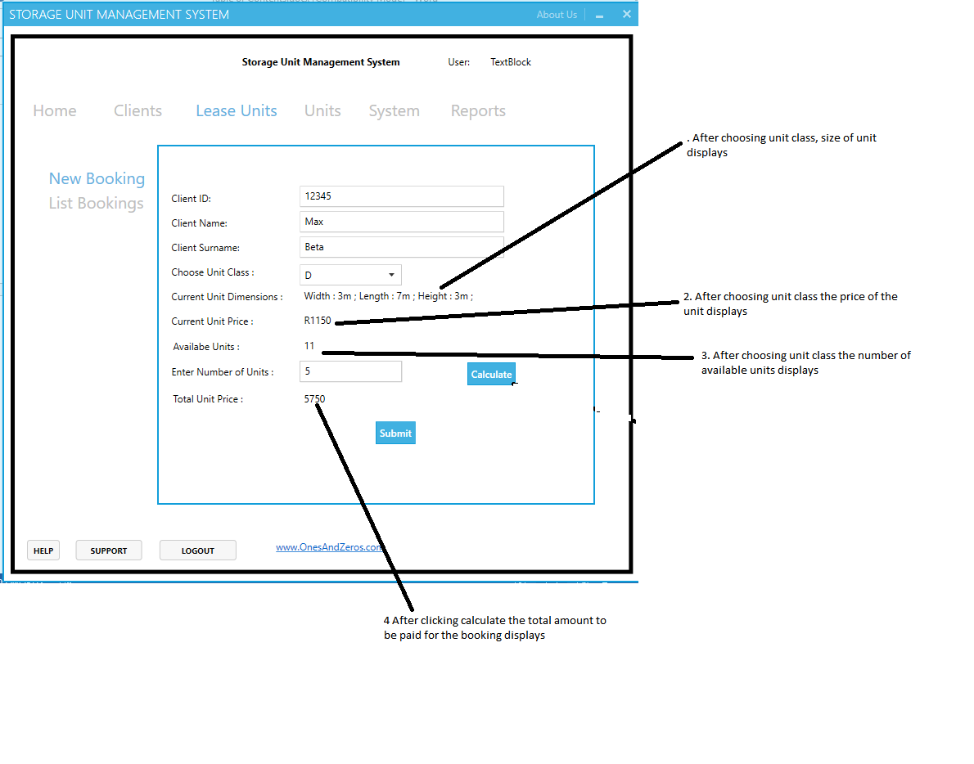

Figure 6.2.1 Completed lease unit interface

Listing Unit bookings

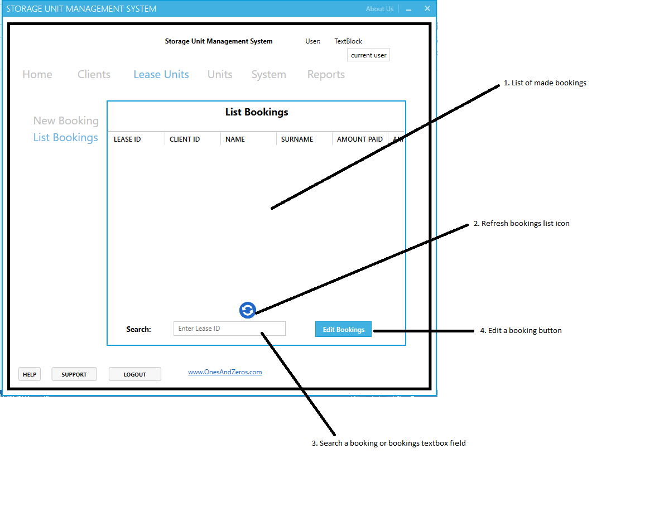

Figure 6.3 Listing unit bookings interface

1. **Click** the refresh button labelled 2 on figure 5.3 to update bookings list
2. **Enter** lease ID in the textbox field labelled 3 to search for a booking
3. **Select** a booking from the booking list labelled 1 on figure 5.3 and **Click** the edit bookings button to edit a booking

Managing Units

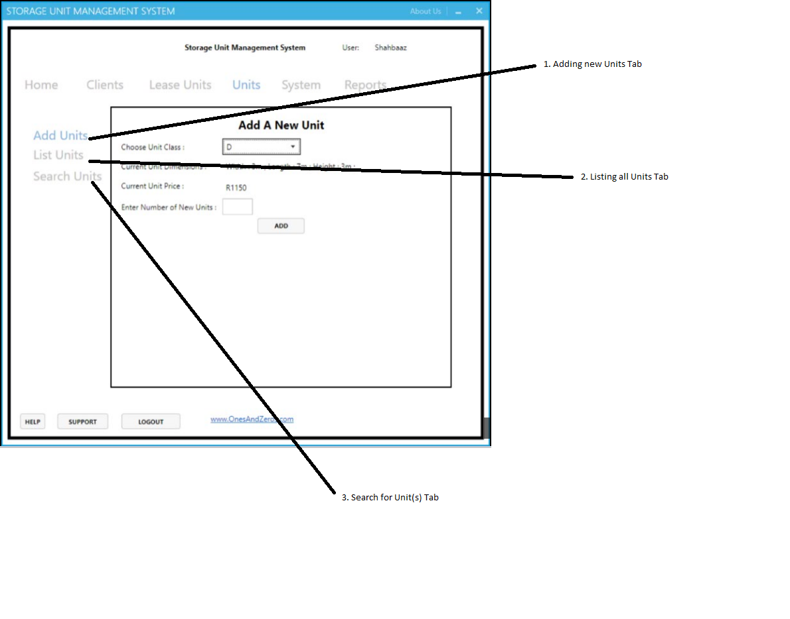

Figure 7.1 Manage Units Interface

Adding a new Unit

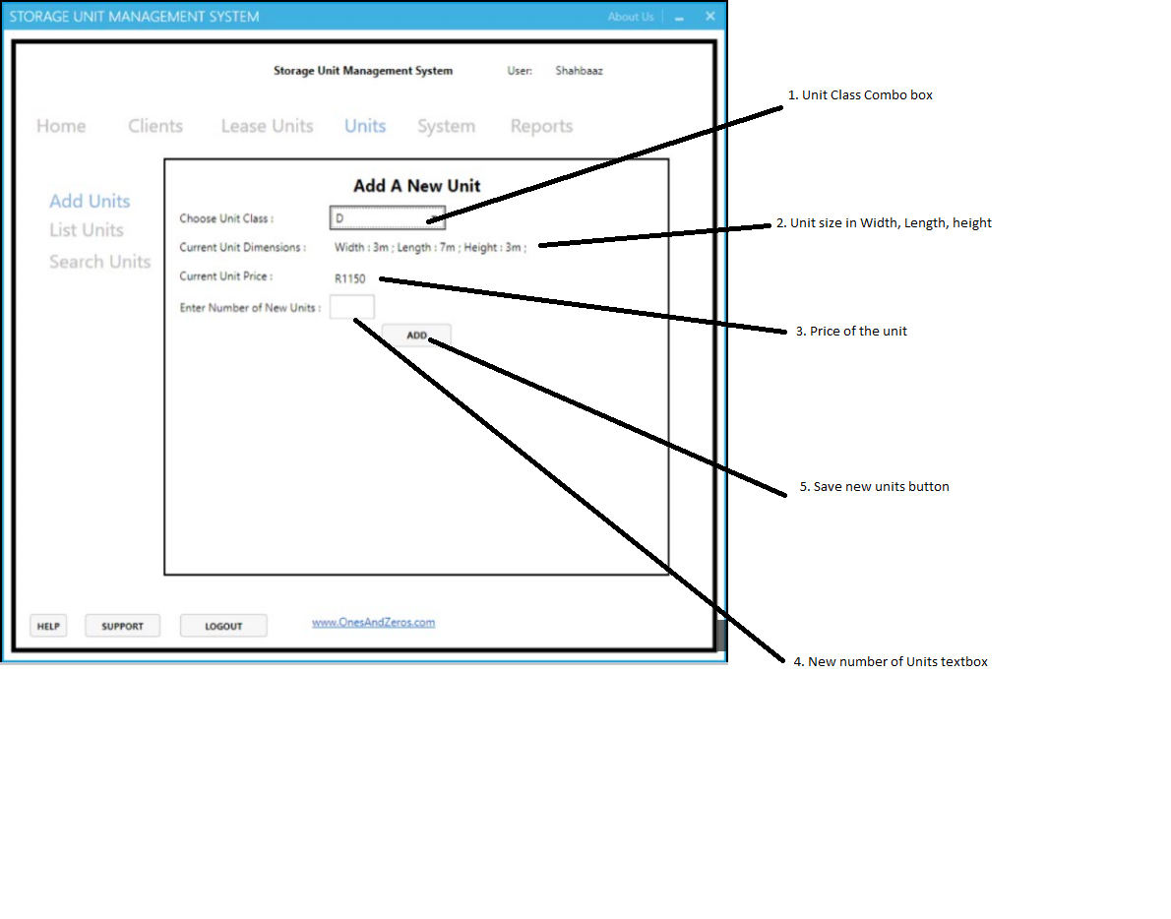

Figure 7.2 adding new unit interface

1. **Select** a unit class(A - F) from the combo box labelled 1 on figure 5.2
2. The price of the unit class will be displayed on the item labelled 2 on figure 5.2
3. The dimensions of the unit class will be displayed on the item labelled 3 on figure 5.2
4. **Enter** the number of units you want to add to the selected unit class in the textbox field labelled 4 on figure 5.2
5. **Click ADD** (labelled 5 on figure 5.2) to save the units added to the selected Unit Class

Listing Units

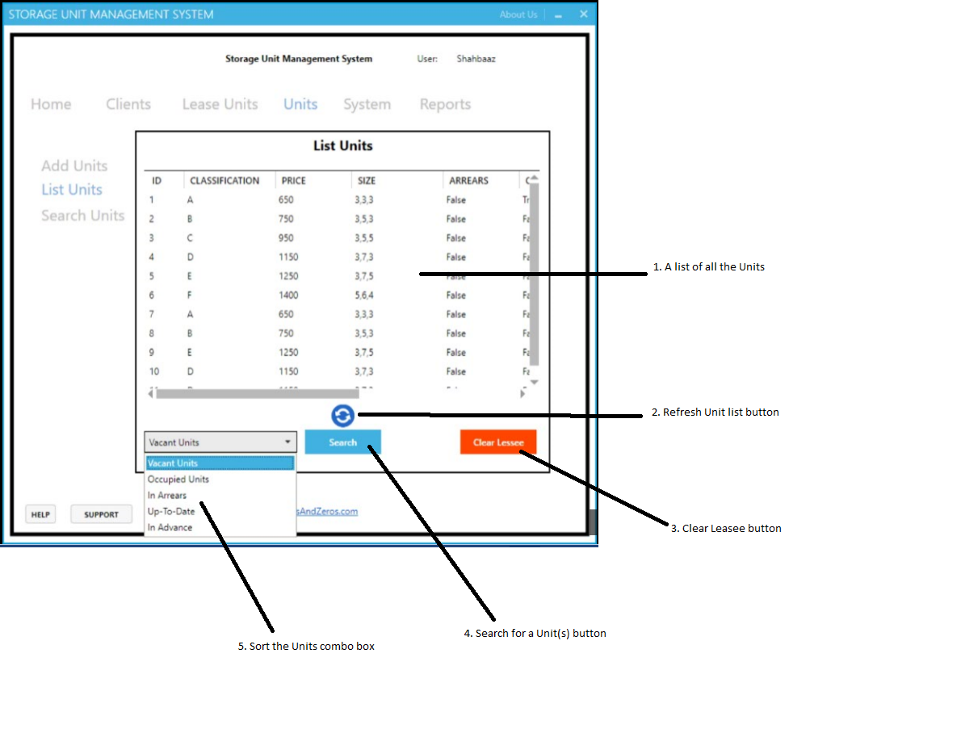

Figure 7.3 List Units interface

1. **Click** the refresh button labelled 2 on figure 5.3 to update the unit list
2. **Click** on the drop box labelled 5 on figure 5.3, options to sort the units will appear
3. **Select** the desired sorting method.

Searching Units

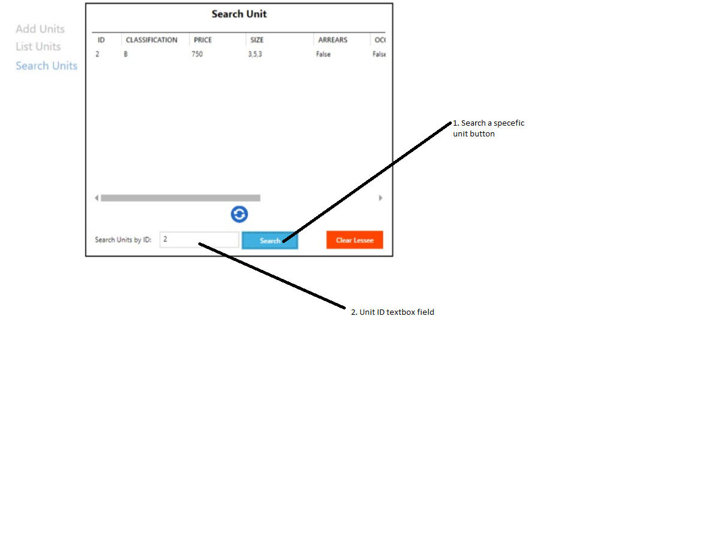

Figure 7.4 searching a specific unit interface

1. **Click** the search button labelled 1 on figure 5.4 to search a specific unit
2. **Enter** unit Id in the textbox field labelled 2 on figure 5.3.1 and **Click** search again to search for the unit.

The searched unit with all its details will show on the list labelled 1 on figure 5.3

Managing the System

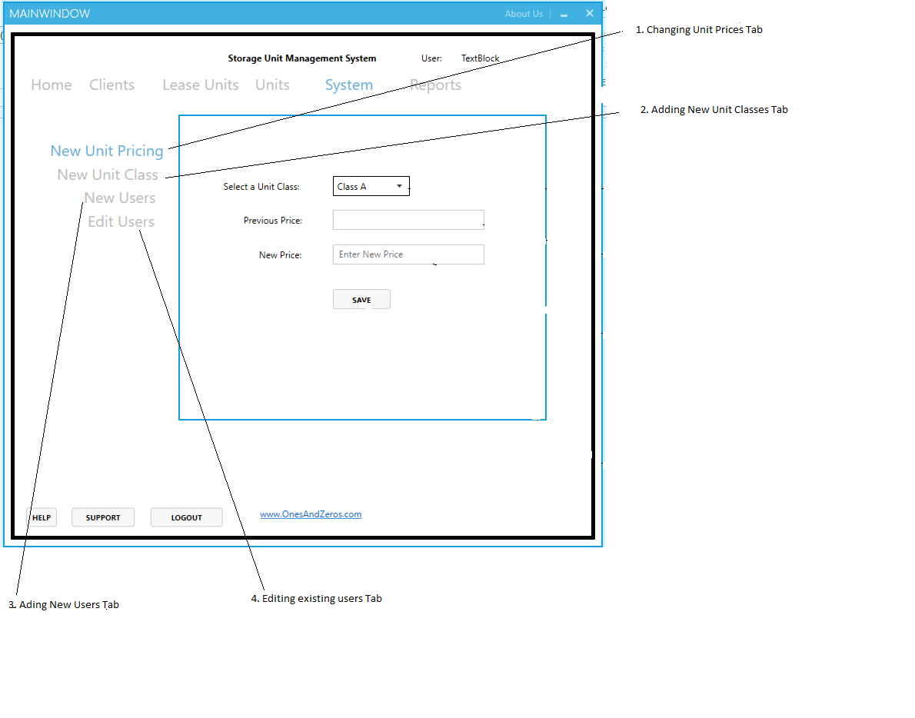

Figure 8.1 Manage System Interface

1. Navigate to the system’s tab see figure 1 to manage the system

Changing Unit Prices

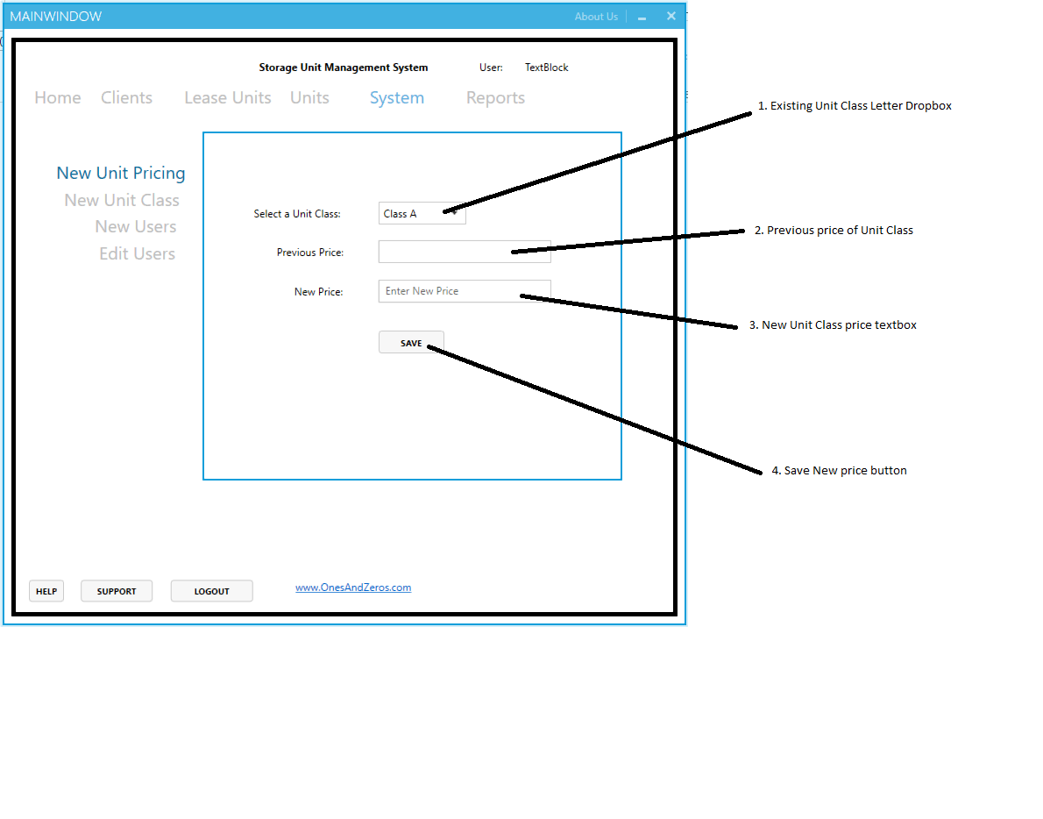

Figure 8.2

1. **Select** a Unit class letter from the drop box labelled 1 on figure 5.2. the previous price of the Unit class will appear in the textbox labelled 2 on figure 5.2
2. **Enter** the Unit class’s new price in the textbox labelled 3 on figure 5.2
3. **Click SAVE** (numbered 4 on figure 5.2)to save the new Unit Class price

Adding New Unit Classes

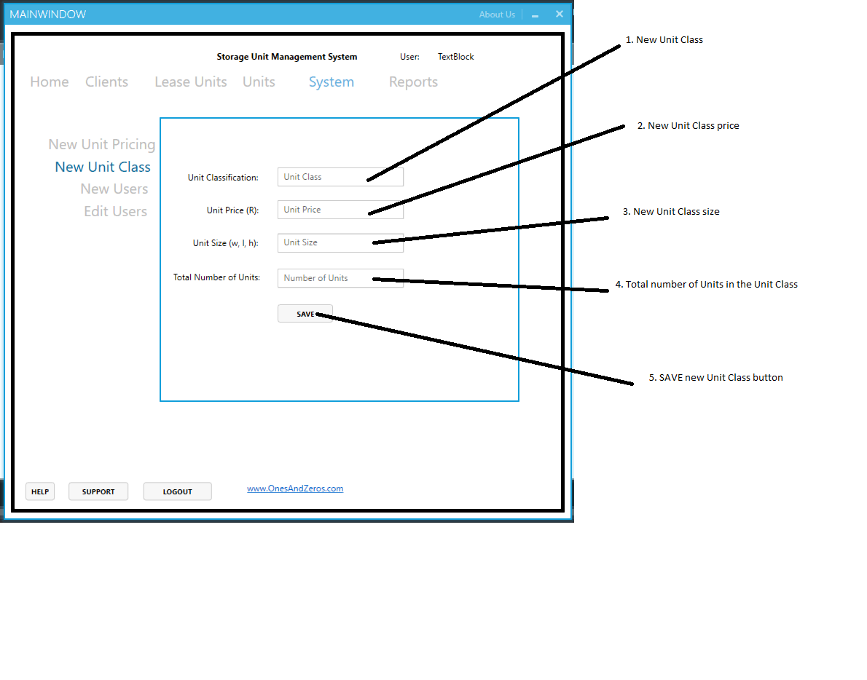

Figure 8.3

1. **Enter** the new Unit class letter in the textbox labelled 1 on figure 5.3
2. **Enter** the price of the new Unit class in the textbox labelled 2 on figure 5.3
3. **Enter** the size of the Units in the textbox labelled 3 on figure 5.3
4. **Enter** the total number of Units in the Unit Class in the textbox labelled 4 on figure 5.3
5. **Click SAVE** (numbered 5 on figure 5.3)to save the new Unit Class

Adding New Users

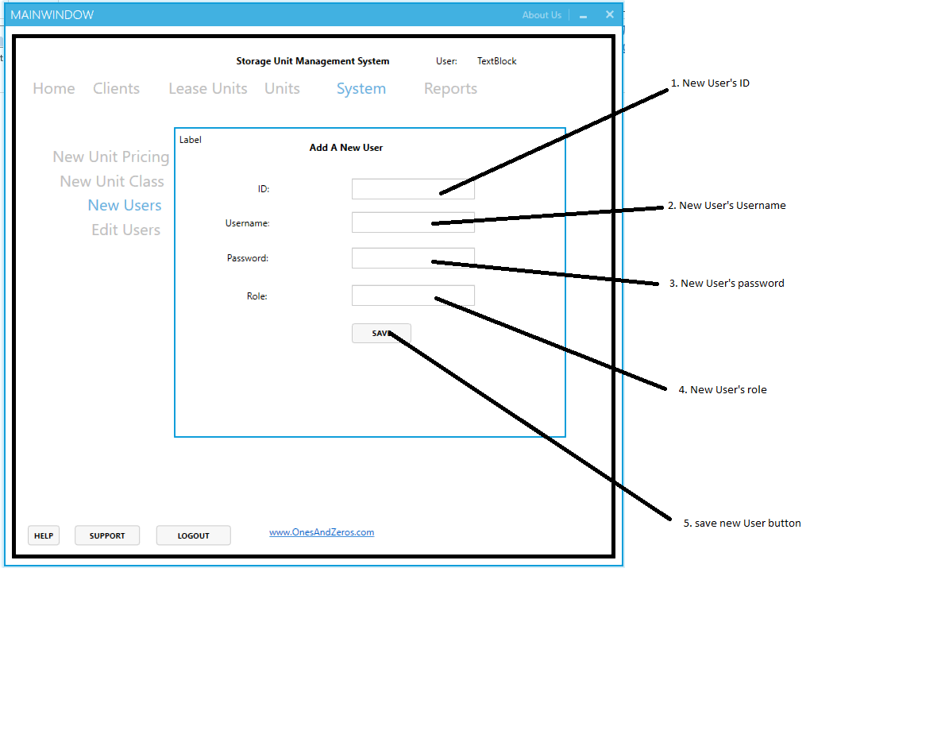

Figure 8.4

1. **Enter** the ID of the new user in the textbox labelled 1 on figure 5.4
2. **Enter** the new User’s username in the textbox labelled 2 figure 5.4
3. **Enter** the password of the new User in the textbox labelled 3 figure 5.4
4. **Enter** the new User’s role in the textbox labelled 4 figure 5.4
5. **Click SAVE** (numbered 5 figure 5.4) to save the new user

Editing existing Users



Figure 8.5

1. **Enter** the existing User’s ID in the textbox labelled 1 on figure 5.5, then **Click GO** to search for the particular user.

The textboxes labelled 2, 3, and 4 will be populated with the relevant information of the searched user.

1. **Click** on any of the textboxes labelled 2 – 4 to change its contents
2. **Click SAVE** (numbered 5 on figure 5.5) to save the changes made for the user